Anthony Cunningham

STAT 3210

4/23/18

**Homework 9 R Code and Output**

#1)

problem1 <- read.table("http://www.stat.uiowa.edu/~ernli/DOEdata/problem0704.txt", header=TRUE)

problem1LM = lm(Life ~ Block + Speed*Geometry*Angle, problem1)

summary(problem1LM)

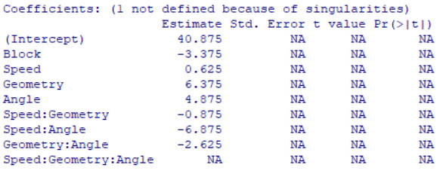

library(gplots)

qqnorm(aov(problem1LM), label = TRUE)



problem1Reduced = lm(Life ~ Block + Speed + Geometry + Angle + Speed:Angle + Geometry:Angle, problem1)

summary(aov(problem1Reduced))

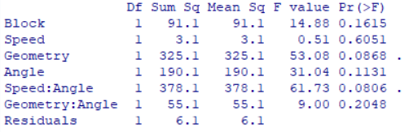

#2)

problem2 <- read.table("http://www.stat.uiowa.edu/~ernli/DOEdata/problem0713.txt", header=TRUE)

problem2LM = lm(UEC ~ Block + Laser*Pulse*Cell*Writing, problem2)

summary(problem2LM)

qqnorm(aov(problem2LM), label = TRUE)



#3)

problem3 <- read.table("http://www.stat.uiowa.edu/~ernli/DOEdata/problem0724.txt", header=TRUE)

problem3Rep1 <- problem3[problem3$Rep == 1,]

Speed <- problem3Rep1$Speed

Geometry <- problem3Rep1$Geometry

Angle <- problem3Rep1$Angle

problem3Rep1$Block <- ifelse(Speed*Geometry*Angle < 0, 1, 2)

problem3Rep1 <- problem3Rep1[order(problem3Rep1$Block),]

problem3Rep2 <- problem3[problem3$Rep == 2,]

Speed <- problem3Rep2$Speed

Geometry <- problem3Rep2$Geometry

problem3Rep2$Block <- ifelse(Speed*Geometry > 0, 1, 2)

problem3Rep2 <- problem3Rep2[order(problem3Rep2$Block),]

problem3Rep3 <- problem3[problem3$Rep == 3,]

Geometry <- problem3Rep3$Geometry

Angle <- problem3Rep3$Angle

problem3Rep3$Block <- ifelse(Geometry*Angle > 0, 1, 2)

problem3Rep3 <- problem3Rep3[order(problem3Rep3$Block),]

(partialConfounding <- rbind(problem3Rep1, problem3Rep2, problem3Rep3))

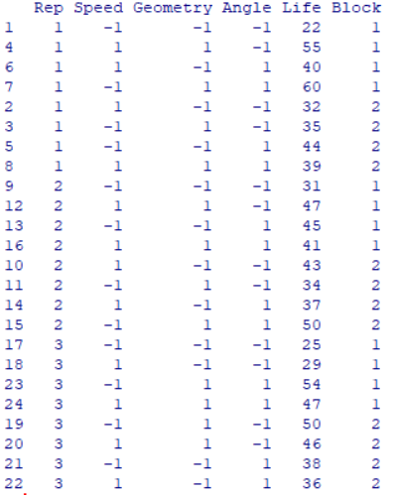

problem3PC = lm(Life~ factor(Block):factor(Rep) + Speed*Geometry*Angle, partialConfounding)

summary(aov(problem3PC))

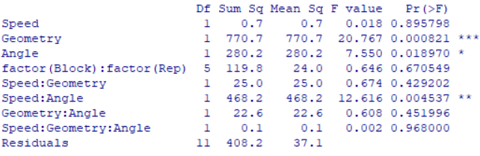

summary(problem3PC)

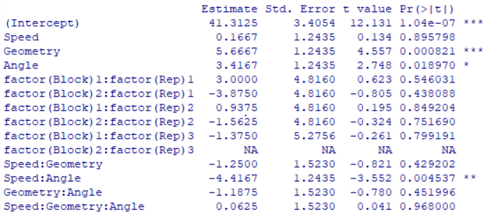

partialConfounding$Blocks <- factor(paste(partialConfounding$Rep, partialConfounding$Block, sep = "-"))

problem3PC = lm(Life ~ Blocks + Speed*Geometry*Angle, partialConfounding)

library(car)

vif(problem3PC)

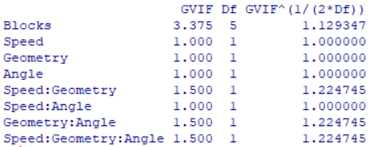

problem3Rep1 <- problem3[problem3$Rep == 1,]

Speed <- problem3Rep1$Speed

Geometry <- problem3Rep1$Geometry

Angle <- problem3Rep1$Angle

problem3Rep1$Block <- ifelse(Speed*Geometry*Angle < 0, 1, 2)

problem3Rep1 <- problem3Rep1[order(problem3Rep1$Block),]

problem3Rep2 <- problem3[problem3$Rep == 2,]

Speed <- problem3Rep2$Speed

Geometry <- problem3Rep2$Geometry

Angle <- problem3Rep2$Angle

problem3Rep2$Block <- ifelse(Speed*Geometry*Angle > 0, 1, 2)

problem3Rep2 <- problem3Rep2[order(problem3Rep2$Block),]

problem3Rep3 <- problem3[problem3$Rep == 3,]

Speed <- problem3Rep3$Speed

Geometry <- problem3Rep3$Geometry

Angle <- problem3Rep3$Angle

problem3Rep3$Block <- ifelse(Speed*Geometry*Angle < 0, 1, 2)

problem3Rep3 <- problem3Rep3[order(problem3Rep3$Block),]

(partialConfounding <- rbind(problem3Rep1, problem3Rep2, problem3Rep3))

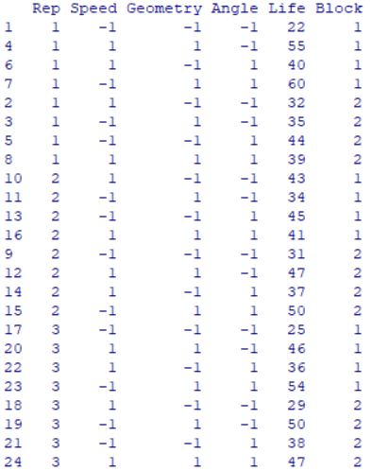

partialConfounding$Blocks <- factor(paste(partialConfounding$Rep, partialConfounding$Block, sep = "-"))

problem3PC = lm(Life ~ Blocks + Speed*Geometry*Angle, partialConfounding)

summary(aov(problem3PC))

summary(problem3PC)

